COVER PAGE

Name: MEGAN BOTSHE

Surname: MASIKO

Course: SYSTEMS DEVELOPMENT

ID: 0103190704082

Module: INTRO TO WEB DESIGN

TABLE OF CONTENTS

|  |  |
| --- | --- |
| 1 | INTRO |
| 2 | INDEX.HTML CODE |
| 3 | STYLE.CSS CODE |
| 4 | MENU.HTML CODE |
| 5 | CONTACT.HTML |
| 6 | CONTACT.CSS |
| 7 | ABOUT.HTML |
| 8 | ABOUT.CSS |
| 9 | IMAGE |
| 10 | REPORT |

INTRODUCTION

This coffee website was inspired by Pink Print/Pink Friday. Where everything is pink including the coffee.

HOME PAGE

<!DOCTYPE html>

<html lange="en">

<head>

    <meta charset="UTE-8">

    <mate http-equiv="X-UA-Compatible" content="IE=edge">

        <mate name="viewport" content="width=decive-width, initial-scale=1.0">

            <link rel="stylesheet" href="style.css">

            <link rel="stylesheet" href="https://cdnjs.cloudflare.com/ajax/libs/font-awesome/6.2.1/css/all.min.css"

                integrity="sha512-MV7K8+y+gLIBoVD591QIYicR65iaqukzvf/nwasF0nqhPay5w/91JmVM2hMDcnK10nGCdVK+iQrJ71zPJQd]w=="

                crossorigin="anonymous" referrerpolicy="no-referrer" />

            <title>PinkCoffee Shop</title>

</head>

<body>

    <header>

        <div class="logo">

            <a href="#">PinkCoffee <span>Shop</span></a>

        </div>

        <nav>

            <ul>

                <li><a href="index.html">Home</a></li>

                <li><a href="menu.html">Menu</a></li>

                <li><a href="about.html">About Us</a></li>

                <li><a href="contact.html">Contact</a></li>

            </ul>

        </nav>

    </header>

    <div class="content">

        <h2> Pink Coffee Shop</h2>

        <p>we provide a variety of uniques and Best Coffee</p>

    </div>

    <div class="menu" id=menu>

        <div class="menu-header">

            <h3>Menu</h3>

            <h4>Pink Coffee Menu</h4>

        </div>

        <div class="menu-content">

            <div class="hot-coffees">

                <div class="hot-coffees-image">

                    <img src="img/latteart.jpg">-

                </div>

                <div class="hot-coffees-body">

                    <h2>Hot Coffee</h2>

                    <label>brewed from roasted coffee bean</label>

                </div>

            </div>

            <div class="cold-coffees">

                <div class="cold-coffees-image">

                    <img src="img/icecoffee.jpg" alt="">

                </div>

                <div class="cold-coffees-body">

                    <h2>Cold Coffee</h2>

                    <label>few ice cubes while blending for a frothy finish!</label>

                </div>

            </div>

            <div class="frappucino-coffees">

                <div class="frappucino-coffees-image">

                    <img src="img/PINKFrappucino.jpg" alt="">

                </div>

                <div class="frappucino-coffees-body">

                    <h2>Frappucino Coffee</h2>

                    <label>flavored syrups and usually topped with whipped cream and or spices</label>

                </div>

            </div>

        </div>

    </div>

    <div class="contact"> id="contact"

        <div class="contact box">

            <div class="contact-image">

                <img src="img/contactpink.jpg">

            </div>

        </div>

        <div class="contact-box">

            <div class="contact-body">

                <form>

                    <h2>Contact Us</h2>

                    <div class="form-content">

                        <input type="text" required>

                        <span></span>

                        <label>Username</label>

                    </div>

                    <div class="form-content">

                        <input type="email" required>

                        <span></span>

                        <label>Email</label>

                    </div>

                    <button type="submit">Send</button>

                </form>

            </div>

        </div>

    </div>

    <div class="footer">

        <div class="social-media">

            <a href="#"><i class="fa-brands fa-facebook"></i></a>

            <a href="#"><i class="fa-brands fa-instagram"></i></a>

            <a href="#"><i class="fa-brands fa-twitter"></i></a>

            <a href="#"><i class="fa-brands fa-whatsapp"></i></a>

            <a href="#"><i class="fa-brands fa-youtube"></i></a>

        </div>

        <div class="copyright">

            <label>Copyright &copy; 2024</label>

        </div>

        <div class="brand">

            <label>Pink <span>Coffee shop</span></label>

        </div>

    </div>

</body>

</html>

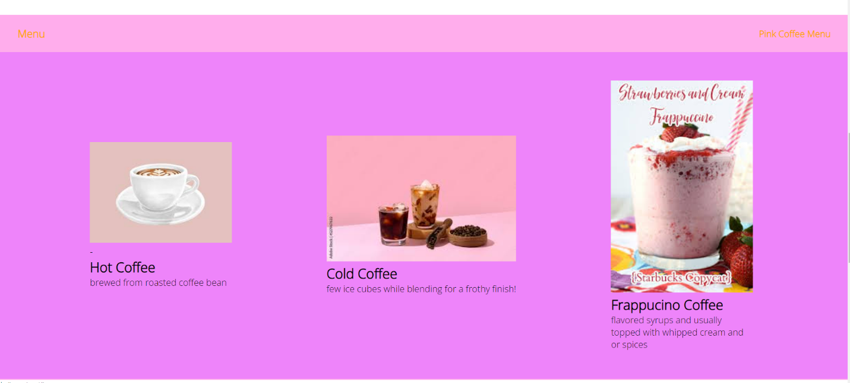

STYLE.CSS

@import url('https://fonts.googleapis.com/css2?family=Open+Sans:wght@300&display=swap/');

* {

    margin: 0;

    padding: 0;

    box-sizing: border-box;

    text-decoration: none;

    list-style: none;

}

html {

    font-family: 'Open sans', sans-serif;

    scroll-behavior: smooth;

}

img {

    width: 100%;

}

header {

    display: flex;

    align-items: center;

    justify-content: space-between;

    padding: 4opx;

    width: 100%;

    height: 70px;

    position: absolute;

    z-index: 1;

}

header .logo a {

    font-size: 30px;

    color: white;

    padding: 15px 30px;

}

header .logo a span {

    color: orange;

}

header nav ul {

    display: flex;

}

header nav ul li a {

    margin: 5px 20px;

    font-size: 18px;

    color: white;

    padding: 10px 10px;

}

header nav ul li a:hover {

    border-bottom: 2px solid white;

}

/* Content */

.content {

    display: flex;

    flex-direction: column;

    align-items: center;

    justify-content: center;

    text-align: center;

    position: relative;

    min-height: 100vh;

    width: 100%;

    background-position: linear-gradient(to bottom right, rgba(255, 119, 189, 0.6), rgba(255, 119, 189, 0.6)), url(img/b;ackcoffee.jpg);

    background-position: center bottom;

    background-position: no-repeat;

    background-position: cover;

    background-position: fixed;

}

.content h2 {

    font-size: 32px;

    padding: 5px;

    color: white;

}

.content p {

    font-size: 22px;

    color: white;

}

/* Menu */

.menu {

    background-color: #ffadec;

    width: 100%;

}

.menu .menu-header {

    display: flex;

    padding: 10px;

    align-items: center;

    justify-content: space-between;

}

.menu-header h3 {

    color: orange;

    padding: 10px 30px;

}

.menu-header h4 {

    color: orange;

    padding: 10px 20px;

}

.menu .menu-content {

    display: flex;

    align-items: center;

    justify-content: space-evenly;

    padding: 50px 0;

    flex-wrap: wrap;

    background-color: #ee84fa;

}

.menu .menu-content .hot-coffees,

.coold-coffees,

.frappucino-coffees {

    width: 250px;

}

.menu .menu-content .hot-coffee .hot-coffee-image img {

    border-radius: 50%;

}

.menu .menu-content .hot-coffee .cold-coffee-image img {

    border-radius: 50%;

}

.menu .menu-content .hot-coffee .frappucino-coffee-image img {

    border-radius: 50%;

}

.menu .menu-content .hot-coffee-body,

.cold-coffee-body,

.frappucino-coffee-body {

    text-align: center;

    margin-top: 10px;

}

.menu .menu-content .hot-coffee-body h2,

.cold-coffee-body h2,

.frappucino-coffee-body h2 {

    color: orange;

}

.menu .menu-content .hot-coffee-body label,

.cold-coffee-body label,

.frappucino-coffee-body label {

    margin-top: 10px;

    color: white;

}

/* Shop */

.shop {

    background-color: #ffadec;

    width: 100%;

}

.shop .shop-header {

    display: flex;

    padding: 10px;

    align-items: center;

    justify-content: space-between;

}

.shop-header h3 {

    color: orange;

    padding: 10px 30px;

}

.shop-header h4 {

    color: orange;

    padding: 10px 20px;

}

.shop-box {

    display: flex;

    align-items: center;

    justify-content: space-evenly;

    background-color: #ee84fa;

    padding: 50px 0;

    flex-wrap: wrap;

}

.shop-box .card {

    width: 280px;

    margin: 20px;

}

.shop-box .card-image {

    width: 100%;

    height: 280px;

    overflow: hidden;

}

.shop-box .card-image img:hover {

    transform: scale(1.1);

    transition: transform .4s ease-in-out;

}

.shop-box .card-body {

    padding: 20px;

    color: white;

    border: 3px solid#ffadec;

}

.shop-box .card-body h3 {

    padding: 10px 0;

}

.shop-box .card-body i {

    color: yellow;

    font-size: 10px;

    position: relative;

    bottom: 5px;

}

.shop-box .card-body .cash{

    font-size: 22px;

    margin-left: 90px;

}

/* Contract */

.contact {

    display: flex;

    flex-wrap: wrap;

    width: 100%;

    border-top: 2px solid #ffadec;

}

.contact .contact-box {

    flex: 1;

}

.contact .contact-box .contact-image,

.contact .contact-box .contact-body {

    height: 100%;

}

.contact img {

    width: 100%;

    height: 100%;

}

.contact-image img {

    opacity: .9;

}

.contact-body {

    background-color: #ee84fa;

    height: 100%;

    border-left: 2px solid #333333;

}

.contact-body form {

    padding: 50px 40px;

    box-sizing: border-box;

}

.contact-body h2 {

    color: orange;

}

form .form-content {

    position: relative;

    margin: 30px 0;

    border-bottom: 2px solid lightgray;

}

form .form-content input {

    width: 100%;

    height: 40px;

    padding: 0 5px;

    font-size: 17px;

    border: none;

    background: none;

    outline: none;

    color: white;

}

form .form-content label {

    position: absolute;

    top: 50%;

    left: 5px;

    color: rgba(153, 12, 132, 0.534);

    transform: translateY(-50%);

    font-size: 17px;

    transition: .5s;

    pointer-events: none;

}

form .form-content span::beofor {

    content: '';

    position: absolute;

    top: 40%;

    left: 0px;

    color:rgba(153, 12, 132, 0.534);

    height: 2px;

    background: orange;

    transform: .4s;

}

form .form-content input:focus-label,

form .form-content input:valid-label{

    top: -5px;

    color: orange;

}

form .form-content input:focus-span::before,

form .form-content input:valid-span::before{

    width: 100%;

}

.contact-body form button{

    padding: 10px 20px;

    font-size: 17px;

    border:none;

    background-color: #ff6600;

    color: white;

    border: 5px;

    cursor: pointer;

    transition: all .4s ease-in;

}

.contact-body form button:hover {

    background-color: #ff6681;

}

MENU PAGE

<!DOCTYPE html>

<html lange="en">

<head>

    <meta charset="UTE-8">

    <mate http-equiv="X-UA-Compatible" content="IE=edge">

        <mate name="viewport" content="width=decive-width, initial-scale=1.0">

            <link rel="stylesheet" href="style.css">

            <link rel="stylesheet" href="https://cdnjs.cloudflare.com/ajax/libs/font-awesome/6.2.1/css/all.min.css"

                integrity="sha512-MV7K8+y+gLIBoVD591QIYicR65iaqukzvf/nwasF0nqhPay5w/91JmVM2hMDcnK10nGCdVK+iQrJ71zPJQd]w=="

                crossorigin="anonymous" referrerpolicy="no-referrer" />

</head>

<body>

    <header>

        <div class="logo">

            <a href="#">PINK<span>Coffee Shop</span></a>

        </div>

        <nav>

            <ul>

                <li><a href="index.html">HOME</a></li>

                <li><a href="menu.html">MENU</a></li>

                <li><a href="about.html">ABOUT US</a></li>

                <li><a href="contact.html">CONTACT</a></li>

            </ul>

        </nav>

    </header>

    <div class="shop" id="shop">

        <div class="shop-header">

            <h3>Pink</h3>

        </div>

        <div class="shop-box">

            <div class="item-1">

                <div class="card">

                    <div class="card-image">

                        <img src="img/boba.jpg">

                    </div>

                    <div class="card-body">

                        <i class="fa-solid fa-star"></i>

                        <i class="fa-solid fa-star"></i>

                        <i class="fa-solid fa-star"></i>

                        <i class="fa-solid fa-star"></i>

                        <i class="fa-solid fa-star-half"></i>

                        <label class="cash">R15.45</label>

                        <h3>Boba</h3>

                        <label>Giving it a fun, chewy and unique texture.</label>

                    </div>

                </div>

            </div>

            <div class="item-2">

                <div class="card">

                    <div class="card-image">

                        <img src="img/espresso.jpg">

                    </div>

                    <div class="card-body">

                        <i class="fa-solid fa-star"></i>

                        <i class="fa-solid fa-star"></i>

                        <i class="fa-solid fa-star"></i>

                        <i class="fa-solid fa-star"></i>

                        <i class="fa-solid fa-star-half"></i>

                        <label class="cash">R50.45</label>

                        <h3>Espresso</h3>

                        <label> coffee served in small, strong shots .</label>

                    </div>

                </div>

            </div>

            <div class="item-3">

                <div class="card">

                    <div class="card-image">

                        <img src="img/healthymatchadalgona.jpg">

                    </div>

                    <div class="card-body">

                        <i class="fa-solid fa-star"></i>

                        <i class="fa-solid fa-star"></i>

                        <i class="fa-solid fa-star"></i>

                        <i class="fa-solid fa-star"></i>

                        <i class="fa-solid fa-star-half"></i>

                        <label class="cash">R45.65</label>

                        <h3>Healthy Matcha Dalgona</h3>

                        <label>“Whipped coffee”, “frothy coffee”, or “fluffy coffee”.</label>

                    </div>

                </div>

            </div>

            <div class="item-4">

                <div class="card">

                    <div class="card-image">

                        <img src="img/super food latte.jpg">

                    </div>

                    <div class="card-body">

                        <i class="fa-solid fa-star"></i>

                        <i class="fa-solid fa-star"></i>

                        <i class="fa-solid fa-star"></i>

                        <i class="fa-solid fa-star"></i>

                        <i class="fa-solid fa-star-half"></i>

                        <label class="cash">R30.45</label>

                        <h3>Super Food latte</h3>

                        <label>Made with fair trade coffee, rich coconut milk, and reishi mushroom powder.</label>

                    </div>

                </div>

            </div>

            <div class="item-5">

                <div class="card">

                    <div class="card-image">

                        <img src="img/coconutcoffe.jpg">

                    </div>

                    <div class="card-body">

                        <i class="fa-solid fa-star"></i>

                        <i class="fa-solid fa-star"></i>

                        <i class="fa-solid fa-star"></i>

                        <i class="fa-solid fa-star"></i>

                        <i class="fa-solid fa-star-half"></i>

                        <label class="cash">R60.45</label>

                        <h3>Coconunt Coffee</h3>

                        <label>Brew the coffee, froth the milk, pour coffee in a mug, and top it with the hot coconut milk.</label>

                    </div>

                </div>

            </div>

            <div class="item-6">

                <div class="card">

                    <div class="card-image">

                        <img src="img/icecreamcoffee.jpg">

                    </div>

                    <div class="card-body">

                        <i class="fa-solid fa-star"></i>

                        <i class="fa-solid fa-star"></i>

                        <i class="fa-solid fa-star"></i>

                        <i class="fa-solid fa-star"></i>

                        <i class="fa-solid fa-star-half"></i>

                        <label class="cash">R40.45</label>

                        <h3>Ice Cream Coffee</h3>

                        <label> Rich and robust flavor with a pronounced coffee taste</label>

                    </div>

                </div>

            </div>

            <div class="item-7">

                <div class="card">

                    <div class="card-image">

                        <img src="img/americanoicecoffee.jpg">

                    </div>

                    <div class="card-body">

                        <i class="fa-solid fa-star"></i>

                        <i class="fa-solid fa-star"></i>

                        <i class="fa-solid fa-star"></i>

                        <i class="fa-solid fa-star"></i>

                        <i class="fa-solid fa-star-half"></i>

                        <label class="cash">R40.45</label>

                        <h3>Americano Ice COffee</h3>

                        <label> For an additional boost, ask your barista to try this with an extra shot.</label>

                    </div>

                </div>

            </div>

            <div class="item-8">

                <div class="card">

                    <div class="card-image">

                        <img src="img/americanocoffee.jpg">

                    </div>

                    <div class="card-body">

                        <i class="fa-solid fa-star"></i>

                        <i class="fa-solid fa-star"></i>

                        <i class="fa-solid fa-star"></i>

                        <i class="fa-solid fa-star"></i>

                        <i class="fa-solid fa-star-half"></i>

                        <label class="cash">R20.45</label>

                        <h3>Americano Coffee</h3>

                        <label>Style drink with a smooth and well-rounded flavor.</label>

                    </div>

                </div>

            </div>

        </div>

    </div>

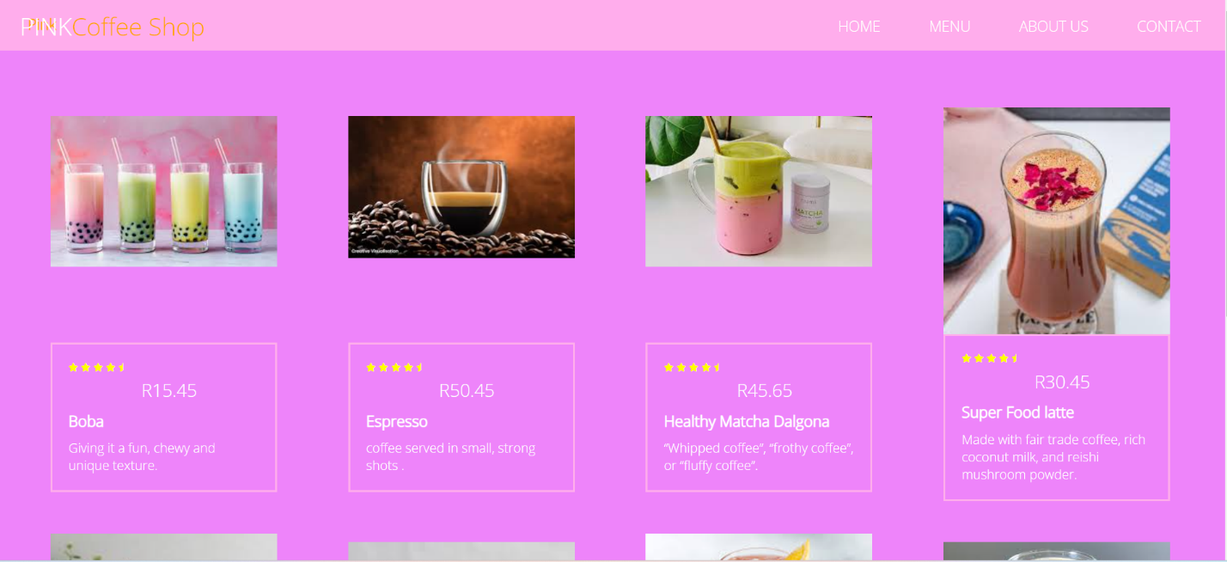

ABOUT PAGE

<!DOCTYPE html>

<html lang="en">

<head>

    <meta charset="UTF-8">

    <title>Document</title>

    <link rel="stylesheet" href="about.css">

    <link rel="stylesheet" href="https://maxcdn.bootstrapcdn.com/font-awesome/4.7.0/css/font-awesome.min.css">

    <link rel="stylesheet" href="https://use.fontawesome.com/releases/v5.8.1/css/all.css"

        integrity="sha384-50oBUHEmvpQ+1lW4y57PTFmhCaXp0ML5d60M1M7uH2+nqUivzIebhndOJK28anvf" crossorigin="anonymous">

    <script src="https://ajax.googleapis.com/ajax/libs/jquery/3.3.1/jquery.min.js"></script>

    <link rel="stylesheet" href="https://www.w3schools.com/w3css/4/w3.css">

    <link rel="stylesheet" href="https://fonts.googleapis.com/css?family=Amatic+SC">

    <script>

        var open = document.getElementById('hamburger');

        var changeIcon = true;

        open.addEventListener("click", function () {

            var overlay = document.querySelector('.overlay');

            var nav = document.querySelector('nav');

            var icon = document.querySelector('.menu-toggle i');

            overlay.classList.toggle("menu-open");

            nav.classList.toggle("menu-open");

            if (changeIcon) {

                icon.classList.remove("fa-bars");

                icon.classList.add("fa-times");

                changeIcon = false;

            }

            else {

                icon.classList.remove("fa-times");

                icon.classList.add("fa-bars");

                changeIcon = true;

            }

        });

    </script>

</head>

<body>

    <div class="menu-toggle" id="hamburger">

        <i class="fas fa-bars"></i>

    </div>

    <div class="overlay"></div>

    <div class="container">

        <nav>

            <h1 class="brand"><a href="index.html">The Cof<span>fe</span>e</a></h1>

            <ul>

                <li><a href="index.html">Home</a></li>

                <li><a href="menu.html"> Menu</a></li>

                <li><a href="about.html">About US</a></li>

                <li><a href="contact.html">Where</a></li>

            </ul>

        </nav>

    </div>

    <div class="w3-container w3-padding-64 " id="about">

        <div class="w3-content">

            <h1 class="w3-center w3-jumbo" style="margin-bottom:64px">About</h1>

            <p>Not all of us can do GREAT things but we can do small things with GREAT LOVE’. </p>

            <img src="img/pinkabout.jpg" style="width:100%" class="w3-margin-top w3-margin-bottom" alt="Restaurant">

            <h1><b>Opening Hours</b></h1>

            <div class="w3-row">

                <div class="w3-col s6">

                    <p>Pink-Mon to Pink-Fri : 07:30am - 12:30pm </p>

                    <p>Saturday : 08:00am - 11:30am </p>

                    <p>Sunday : close @ 11:00am</p>

                </div>

                <div class="w3-col s6">

                    <p>Holidays Day : 07:30am - 15:00pm</p>

                    <p>Week days: 07:30am - 17:00pm</p>

                </div>

            </div>

        </div>

    </div>

</body>

</html>

ABOUT.CSS

/* @import url('https://fonts.googleapis.com/css?family=Roboto'); */

*{

    margin: 0;

    padding: 0;

    box-sizing: border-box;

}

html{

    font-size: 10px;

    font-family: "Roboto Cn", sans-serif;

}

body{

    background: linear-gradient(to bottom, rgba(253, 137, 230, 0.75), rgba(0,0,0,.75)), url("cafe1.jpg") center no-repeat;

    background-size: cover;

}

.w3-container {

    background-color: rgba(0,0,0,.25);

    color: 0,0,0,.75;

    font-family: "Yu Gothic Light", sans-serif;

}

h1,h2,h3,h4,h5,h6 {

    font-family: "Roboto Cn", sans-serif;

}

.w3-input

{

    color: black;

}

h5{

    font-size: 50px;

}

p{

    font-size: 1.3rem;

    font-family: "Yu Gothic Light", sans-serif;

}

a{

    text-decoration: none;

    color: #eee;

}

.w3-button:hover{

    background-color: gold;

}

/*

header{

    width: 100%;

    height: 100vh;

    background: linear-gradient(to bottom, rgba(0,0,0,.3), rgba(0,0,0,.5)), url("home1.jpg") center no-repeat;

    background-size: cover;

    position: relative;

  overflow: hidden;

} */

.container{

    max-width: 120rem;

    width: 90%;

    margin: 0 auto;

}

.menu-toggle{

    position: fixed;

    top: 2.5rem;

    right: 2.5rem;

    color: #eeeeee;

    font-size: 3rem;

    cursor: pointer;

    z-index: 1000;

    display: none;

}

nav{

    padding-top: .5rem;

    display: flex;

    justify-content: space-between;

    align-items: center;

    text-transform: uppercase;

    font-size: 1.1rem;

}

.brand{

    font-size: 3rem;

    font-weight: 300;

    transform: translateX(-100rem);

    animation: slideIn .5s forwards;

    color: white;

}

.brand span{

    color: gold;

}

nav ul{

    display: flex;

}

nav ul li{

    list-style: none;

    transform: translateX(100rem);

    animation: slideIn .5s forwards;

    margin-top: 1rem;

}

nav ul li:nth-child(1){

    animation-delay: 0s;

}

nav ul li:nth-child(2){

    animation-delay: .5s;

}

nav ul li:nth-child(3){

    animation-delay: 1s;

}

nav ul li:nth-child(4){

    animation-delay: 1.5s;

}

nav ul li a{

    padding: 1rem 0;

    margin: 0 6rem;

    position: relative;

    letter-spacing: 2px;

    color: rgba(255, 255, 255, 0.503);

}

nav ul li a:last-child{

    margin-right: 0;

}

 nav ul li a::before,

nav ul li a::after{

    content: '';

    position: absolute;

    width: 100%;

    height: 2px;

    background-color: gold;

    left: 0;

    transform: scaleX(0);

    transition: all .5s;

}

nav ul li a::before{

    top: 0;

    transform-origin: left;

}

nav ul li a::after{

    bottom: 0;

    transform-origin: right;

}

.overlay{

    background-color: rgba(0,0,0,.95);

    position: fixed;

    right: 0;

    left: 0;

    top: 0;

    bottom: 0;

    transition: opacity 650ms;

    transform: scale(0);

    opacity: 0;

  display: none;

}

nav ul li a:hover::before,

nav ul li a:hover::after{

    transform: scaleX(1);

}

@keyframes slideIn {

    from{

    }

    to{

        transform: translateX(0);

    }

}

@media screen and (max-width: 700px){

    .menu-toggle{

        display: block;

    }

    nav{

        padding-top: 0;

        display: none;

        flex-direction: column;

        justify-content: space-evenly;

        align-items: center;

        height: 100vh;

        text-align: center;

    }

    nav ul{

        flex-direction: column;

    }

    nav ul li{

        margin-top: 2rem;

    }

    nav ul li a{

        margin: 0;

        font-size: 1.5rem;

    }

    .brand{

        font-size: 5rem;

    }

  .overlay.menu-open,

  nav.menu-open{

      display: flex;

      transform: scale(1);

      opacity: 1;

  }

}

CONTACT PAGE

<!DOCTYPE html>

<html lang="en">

<head>

    <meta charset="UTF-8">

    <title>Document</title>

    <link rel="stylesheet" href="contact.css">

    <link rel="stylesheet" href="https://maxcdn.bootstrapcdn.com/font-awesome/4.7.0/css/font-awesome.min.css">

    <link rel="stylesheet" href="https://use.fontawesome.com/releases/v5.8.1/css/all.css"

        integrity="sha384-50oBUHEmvpQ+1lW4y57PTFmhCaXp0ML5d60M1M7uH2+nqUivzIebhndOJK28anvf" crossorigin="anonymous">

    <script src="https://ajax.googleapis.com/ajax/libs/jquery/3.3.1/jquery.min.js"></script>

    <link rel="stylesheet" href="https://www.w3schools.com/w3css/4/w3.css">

    <link rel="stylesheet" href="https://cdnjs.cloudflare.com/ajax/libs/font-awesome/4.7.0/css/font-awesome.min.css">

    <link rel="stylesheet" href="https://fonts.googleapis.com/css?family=Amatic+SC">

    <script>

        var open = document.getElementById('hamburger');

        var changeIcon = true;

        open.addEventListener("click", function () {

            var overlay = document.querySelector('.overlay');

            var nav = document.querySelector('nav');

            var icon = document.querySelector('.menu-toggle i');

            overlay.classList.toggle("menu-open");

            nav.classList.toggle("menu-open");

            if (changeIcon) {

                icon.classList.remove("fa-bars");

                icon.classList.add("fa-times");

                changeIcon = false;

            }

            else {

                icon.classList.remove("fa-times");

                icon.classList.add("fa-bars");

                changeIcon = true;

            }

        });

    </script>

</head>

<body>

    <div class="menu-toggle" id="hamburger">

        <i class="fas fa-bars"></i>

    </div>

    <div class="overlay"></div>

    <div class="container">

        <nav>

            <h1 class="brand"><a href="index.html">The Cof<span>fe</span>e</a></h1>

            <ul>

                <li><a href="index.html">Home</a></li>

                <li><a href="menu.html"> Our Menu</a></li>

                <li><a href="about.html">About</a></li>

                <li><a href="contact.html">Where</a></li>

            </ul>

        </nav>

    </div>

    <!-- Contact -->

    <div class="w3-container" id="where" style="padding-bottom:32px;">

        <div class="w3-content" style="max-width:700px">

            <h5 class="w3-center w3-padding-48" style="font-size: 35px;"><span>WHERE TO FIND US</span></h5>

            <p><i class="fa fa-map-marker" style="color: orange;"></i>

                1970 Wit Rd ,Johannesburg Gauteng 2031 </p>

            <br>

            <img src="img/contactpink.jpg" class="w3-image" style="width:100% ; height: 450px;">

            <br>

            <p><span class="w3-tag">FYI!</span> Never give up on what sets your soul on fire. Your dreams are worth

                fighting for.</p>

            <p><strong>Reserve</strong> a table, ask for today's special or just send us a message:</p>

            <br>

            <form action="" target="_blank">

                <p><input class="w3-input w3-padding-16 " style="color: black;" type="text" placeholder="Name" required

                        name="Name"></p>

                <p><input class="w3-input w3-padding-16 " type="number" placeholder="How many people" required

                        name="People"></p>

                <p><input class="w3-input w3-padding-16 " type="datetime-local" placeholder="Date and time" required

                        name="date" value="2017-11-16T20:00"></p>

                <p><input class="w3-input w3-padding-16 " type="text" placeholder="Message \ Special requirements"

                        required name="Message"></p>

                <p><button class="w3-button w3-black" type="submit">SEND MESSAGE</button></p>

            </form>

        </div>

    </div>

    <br></br>

</body>

</html>

CONTACT.CSS

*{

    margin: 0;

    padding: 0;

    box-sizing: border-box;

}

html{

    font-size: 10px;

    font-family: "Roboto Cn", sans-serif;

}

body{

    background: linear-gradient(to bottom, rgba(253, 137, 230, 0.75), rgba(0,0,0,.75)), url("cafe1.jpg") center no-repeat;

    background-size: cover;

}

.w3-container {

    background-color: rgba(0,0,0,.25);

    color: 0,0,0,.75;

    font-family: "Yu Gothic Light", sans-serif;

}

h1,h2,h3,h4,h5,h6 {

    font-family: "Roboto Cn", sans-serif;

}

.w3-input

{

    color: black;

}

h5{

    font-size: 50px;

}

p{

    font-size: 1.3rem;

    font-family: "Yu Gothic Light", sans-serif;

}

a{

    text-decoration: none;

    color: #eee;

}

.w3-button:hover{

    background-color: gold;

}

/*

header{

    width: 100%;

    height: 100vh;

    background: linear-gradient(to bottom, rgba(0,0,0,.3), rgba(0,0,0,.5)), url("home1.jpg") center no-repeat;

    background-size: cover;

    position: relative;

  overflow: hidden;

} */

.container{

    max-width: 120rem;

    width: 90%;

    margin: 0 auto;

}

.menu-toggle{

    position: fixed;

    top: 2.5rem;

    right: 2.5rem;

    color: #eeeeee;

    font-size: 3rem;

    cursor: pointer;

    z-index: 1000;

    display: none;

}

nav{

    padding-top: .5rem;

    display: flex;

    justify-content: space-between;

    align-items: center;

    text-transform: uppercase;

    font-size: 1.1rem;

}

.brand{

    font-size: 3rem;

    font-weight: 300;

    transform: translateX(-100rem);

    animation: slideIn .5s forwards;

    color: white;

}

.brand span{

    color: gold;

}

nav ul{

    display: flex;

}

nav ul li{

    list-style: none;

    transform: translateX(100rem);

    animation: slideIn .5s forwards;

    margin-top: 1rem;

}

nav ul li:nth-child(1){

    animation-delay: 0s;

}

nav ul li:nth-child(2){

    animation-delay: .5s;

}

nav ul li:nth-child(3){

    animation-delay: 1s;

}

nav ul li:nth-child(4){

    animation-delay: 1.5s;

}

nav ul li a{

    padding: 1rem 0;

    margin: 0 6rem;

    position: relative;

    letter-spacing: 2px;

    color: rgba(255, 255, 255, 0.503);

}

nav ul li a:last-child{

    margin-right: 0;

}

 nav ul li a::before,

nav ul li a::after{

    content: '';

    position: absolute;

    width: 100%;

    height: 2px;

    background-color: gold;

    left: 0;

    transform: scaleX(0);

    transition: all .5s;

}

nav ul li a::before{

    top: 0;

    transform-origin: left;

}

nav ul li a::after{

    bottom: 0;

    transform-origin: right;

}

.overlay{

    background-color: rgba(0,0,0,.95);

    position: fixed;

    right: 0;

    left: 0;

    top: 0;

    bottom: 0;

    transition: opacity 650ms;

    transform: scale(0);

    opacity: 0;

  display: none;

}

nav ul li a:hover::before,

nav ul li a:hover::after{

    transform: scaleX(1);

}

@keyframes slideIn {

    from{

    }

    to{

        transform: translateX(0);

    }

}

@media screen and (max-width: 700px){

    .menu-toggle{

        display: block;

    }

    nav{

        padding-top: 0;

        display: none;

        flex-direction: column;

        justify-content: space-evenly;

        align-items: center;

        height: 100vh;

        text-align: center;

    }

    nav ul{

        flex-direction: column;

    }

    nav ul li{

        margin-top: 2rem;

    }

    nav ul li a{

        margin: 0;

        font-size: 1.5rem;

    }

    .brand{

        font-size: 5rem;

    }

  .overlay.menu-open,

  nav.menu-open{

      display: flex;

      transform: scale(1);

      opacity: 1;

  }

}

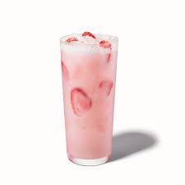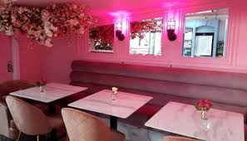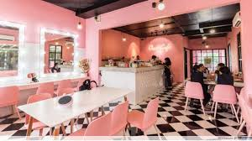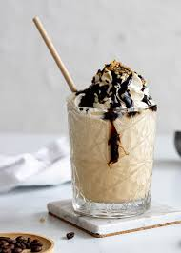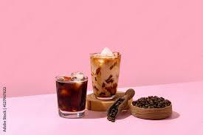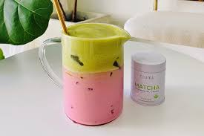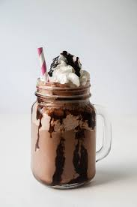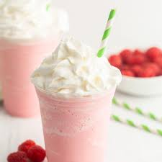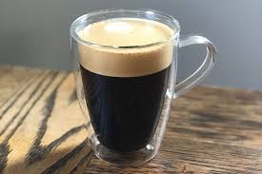

Report

Explaining your design choices, challenges faced, and what you learned during the project.

This description of my coffee shop comes from an authentic side of me. Usually, coffee shops websites are dark. But I had to brighten things up.

But also, while trying to insert some hover on the nav. And trying to use the hamburger code.

That was the most challenging code. I had to separate my CSS code. Separating them was the best way I could bring to life my ideas. I tried to mix the codes but ended up getting code that would not respond. The responsive code was a bit tricky. It’s easy when it comes to the navigation. But below that it gets even harder.